Project: Predictive Analytics Capstone

Complete each section. When you are ready, save your file as a PDF document and submit it here: <https://coco.udacity.com/nanodegrees/nd008/locale/en-us/versions/1.0.0/parts/7271/project>

## Task 1: Determine Store Formats for Existing Stores

1. What is the optimal number of store formats? How did you arrive at that number?

A company currently has 85 grocery stores. Up until now, the company has treated all stores, similarly, shipping the same amount of product to each store. This is beginning to cause problems as stores are suffering from product surpluses in some product categories and shortages in others. To remedy the product surplus and shortages, the company wants to introduce different store formats with no more than 40 individual stores per store format. The purpose of this report is to provide analytical support to make decisions about store formats and inventory planning.

In order to determine the best number of store formats to use. A k-centroids analysis was done using k-means clustering method for k= 3,4,5,6.

Below are the results:

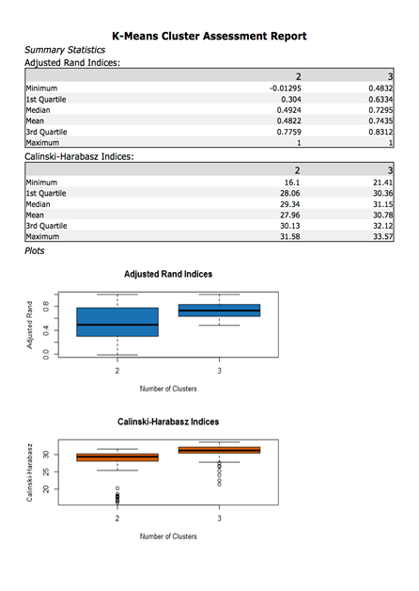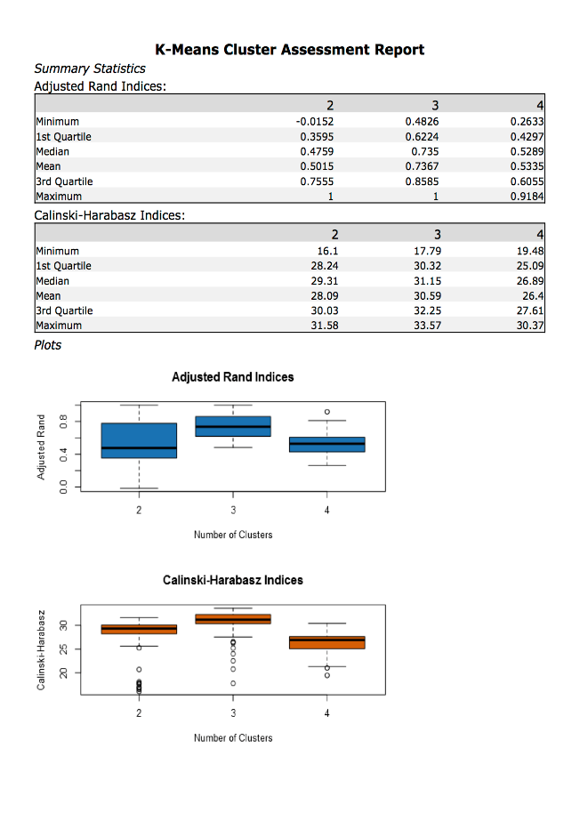

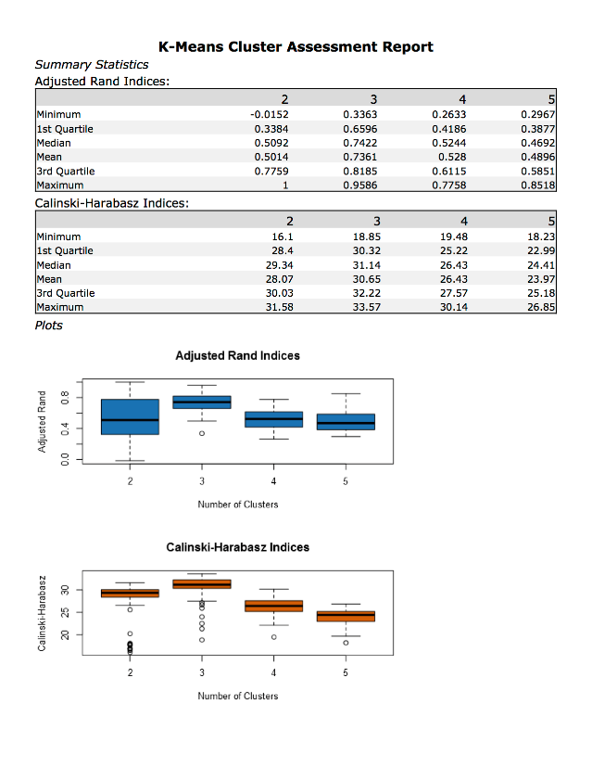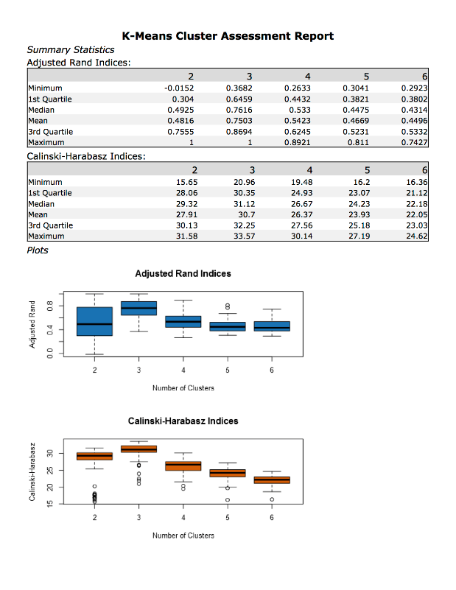

From the above diagnostics, cluster 3 seems to be the best cluster and therefore I will use cluster 3 as my base to compare the number of k terms. Comparing cluster 3, between all the differing k terms, it looks like using k=3 for my analysis offers the best results with cluster 3 having the tightest range and highest mean when k=3.

The optimal number of store formats in my opinion is 3.

1. How many stores fall into each store format?

|  |  |
| --- | --- |
| Store Format | Number of stores |
| 1 | 23 |
| 2 | 29 |
| 3 | 33 |

1. Based on the results of the clustering model, what is one way that the clusters differ from one another?

Below is the summary of the cluster analysis for k=3.

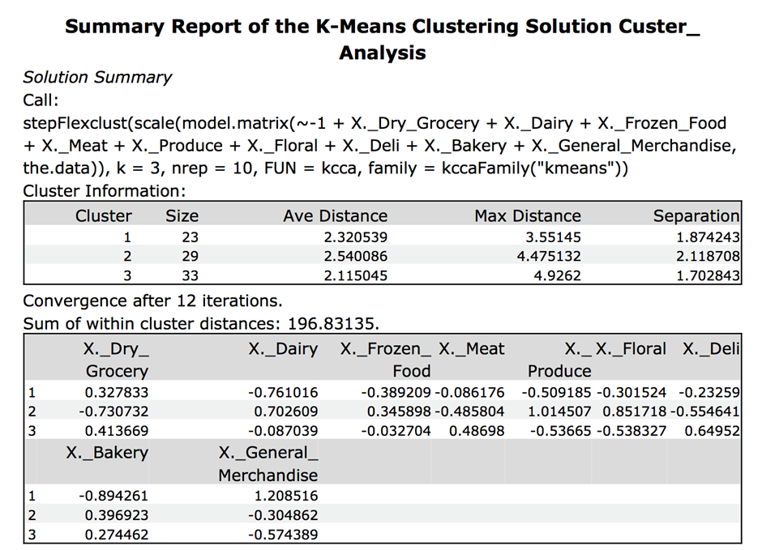

1. Please provide a Tableau visualization (saved as a Tableau Public file) that shows the location of the stores, uses color to show cluster, and size to show total sales.

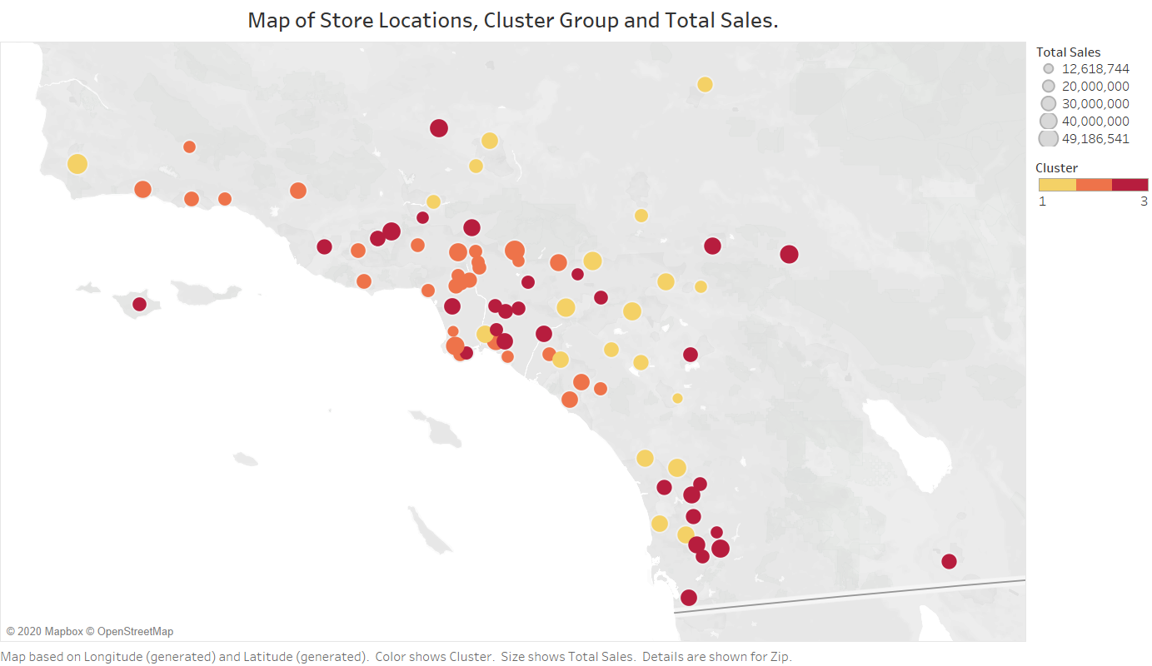

## Task 2: Formats for New Stores

1. What methodology did you use to predict the best store format for the new stores? Why did you choose that methodology? (Remember to Use a 20% validation sample with Random Seed = 3 to test differences in models.)

The grocery store chain has 10 new stores opening at the beginning of the year. The company wants to determine which store format each of the new stores should have. However, we do not have sales data for these new stores yet, so we will have to determine the format using each of the new store’s demographic data.

In order to predict the store formats for the new stores, demographic data from StoreDemographicData.csv was used. All the variables were kept as predictor variables and run through a boosted, decision tree and random forest model. An 80/20 split of the data was used for training and validating the models.

The comparison of the model is as follows,

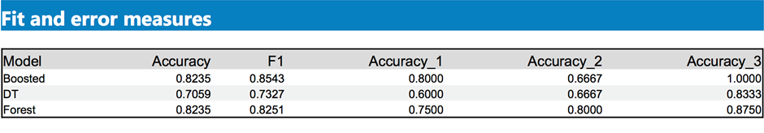

Based on the above results, I have decided to use the Boosted, due to the higher F1 score of the model as my deciding factor.

The 3 most important variables for the Boosted model are:

* + Variable
  + Age0to9
  + HVal750KPlus
  + EdHSGrad

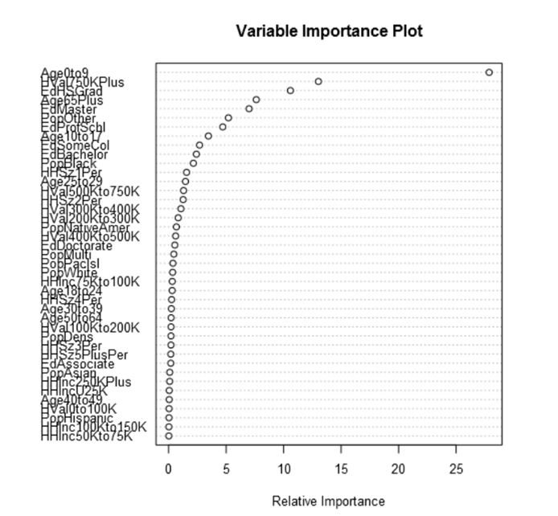

1. What format do each of the 10 new stores fall into? Please fill in the table below.

|  |  |
| --- | --- |
| Store Number | Segment |
| S0086 | 3 |
| S0087 | 2 |
| S0088 | 3 |
| S0089 | 2 |
| S0090 | 2 |
| S0091 | 1 |
| S0092 | 2 |
| S0093 | 1 |
| S0094 | 2 |
| S0095 | 2 |

## Task 3: Predicting Produce Sales

1. What type of ETS or ARIMA model did you use for each forecast? Use ETS(a,m,n) or ARIMA(ar, i, ma) notation. How did you come to that decision?

The company has requested a monthly forecast for produce sales for the full year of 2016 for both existing and new stores. To do so, historical monthly produce sales is required for existing stores. As the supplied historic data contains monthly sales measured over a continuous time period with sequential and equal time intervals and only one data point per time unit, the historic data is enough to carry out a time series analysis. To assess the performance of our time series analysis, a comparison of models will be conducted on a holdout sample. This holdout sample will contain the most recent 6 months of the historical sales data.

The data used here is sales for produce only per month for all stores aggregated.

A decomposition plot of the time series,

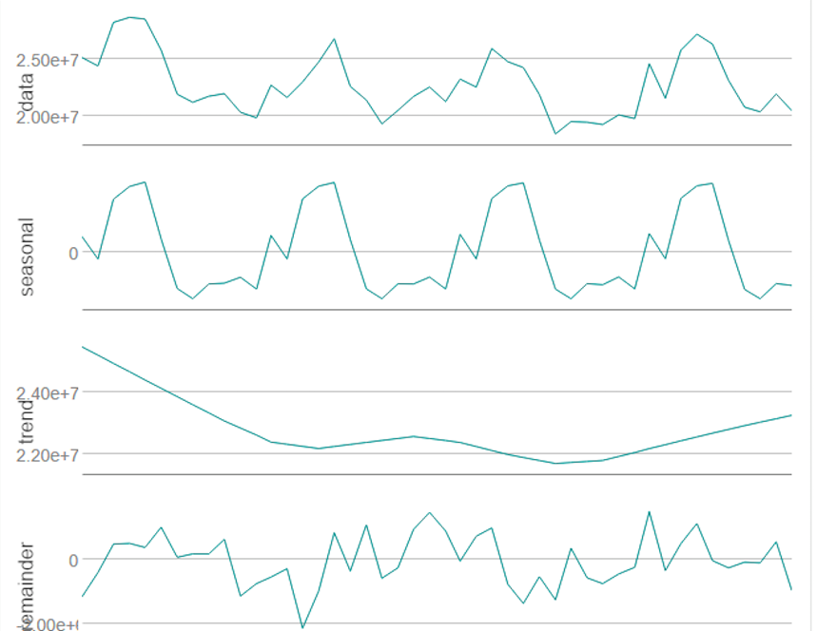

Both ETS and ARIMA models were run for comparison. Analysis of the initial time series decomposition plots below allowed further analysis of model parameters to be established.

From the above decomposition plots, I can see that the Error element is increasing, Trend element is non-existent and the Seasonal element is also increasing, therefore an ETS(M,N,M) will be used. As for the ARIMA model, I have set the model to calculate the elements automatically.

For comparison, a holdout period of 12 periods was used to validate the ETS and ARIMA model.

Below is the ETS(M,N,M) in-sample summary.

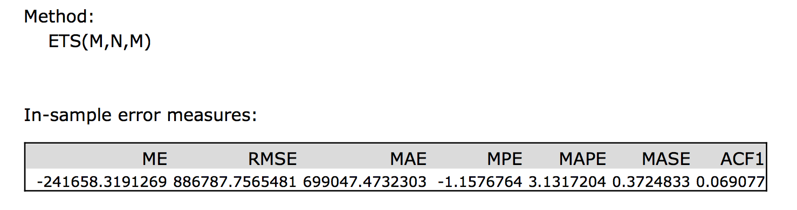

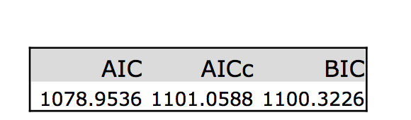

The ARIMA(1,0,0)(0,1,0)12 model in-sample summary.

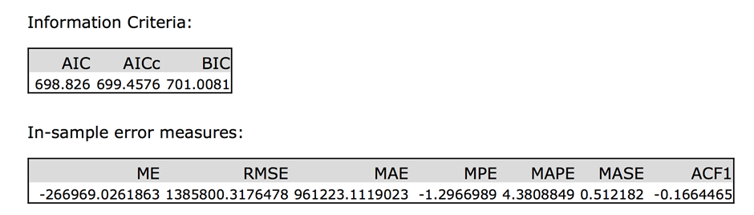

The ETS(M,N,M) will be used for forecasting due to the model having lower error values compared to the ARIMA model.

1. Please provide a table of your forecasts for existing and new stores. Also, provide visualization of your forecasts that includes historical data, existing stores forecasts, and new stores forecasts.

Below is a table of sales forecasts for existing stores, new stores and both new and existing stores combined.

|  |  |  |  |  |
| --- | --- | --- | --- | --- |
| Month | Year | Existing Store Sales Forecast | New Store Sales Forecast | Combined Store Sales Forecast |
| 1 | 2016 | 21,381,830.22 | 2,600,354.85 | 23,982,185.07 |
| 2 | 2016 | 21,081,311.62 | 2,505,198.46 | 23,586,510.07 |
| 3 | 2016 | 24,502,171.96 | 2,889,940.32 | 27,392,112.28 |
| 4 | 2016 | 22,352,993.13 | 2,743,927.30 | 25,096,920.43 |
| 5 | 2016 | 25,331,350.65 | 3,110,813.81 | 28,442,164.46 |
| 6 | 2016 | 26,330,255.79 | 3,191,154.55 | 29,521,410.34 |
| 7 | 2016 | 25,715,514.09 | 3,219,369.78 | 28,934,883.87 |
| 8 | 2016 | 23,458,933.07 | 2,852,751.79 | 26,311,684.87 |
| 9 | 2016 | 21,801,458.48 | 2,543,602.66 | 24,345,061.14 |
| 10 | 2016 | 21,509,922.65 | 2,477,331.44 | 23,987,254.09 |
| 11 | 2016 | 22,619,212.99 | 2,569,169.56 | 25,188,382.55 |
| 12 | 2016 | 21,582,321.09 | 2,535,481.94 | 24,117,803.02 |

Below is a tableau plot of the sales forecasts for existing, new and the combined store sales for produce only.

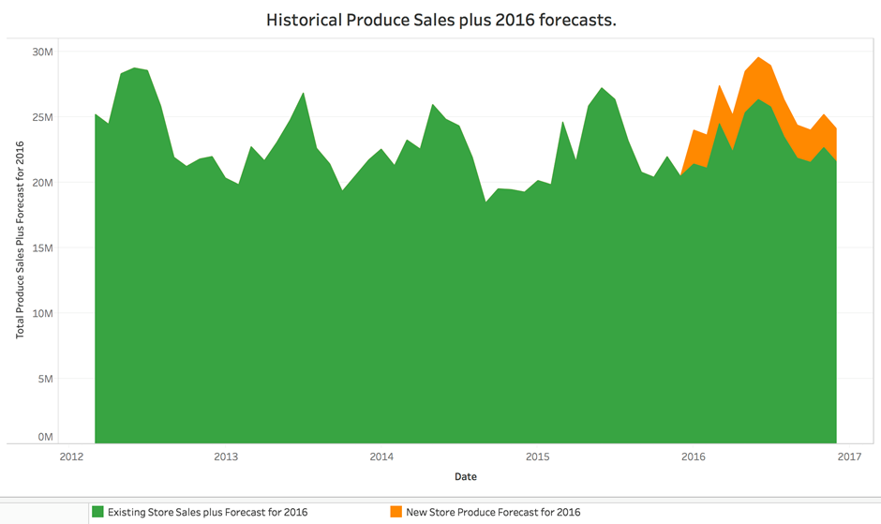

Alteryx Workflows

Task 1 Data Preparation

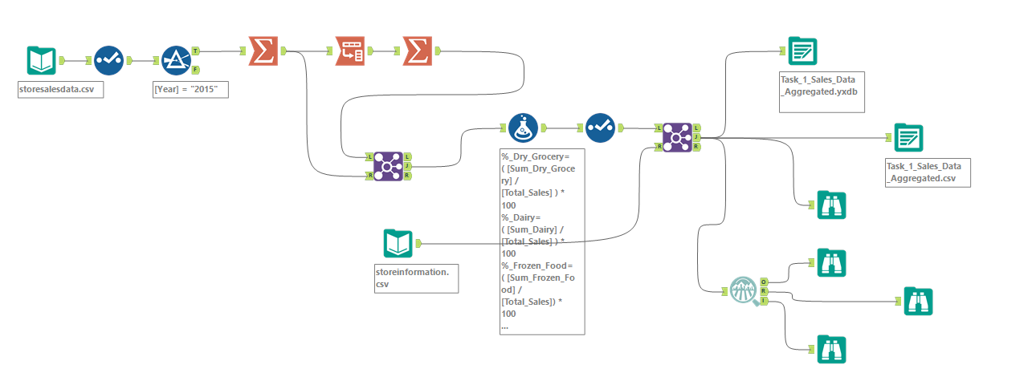

Task 1 Clustering



Task 1 Cluster Analysis

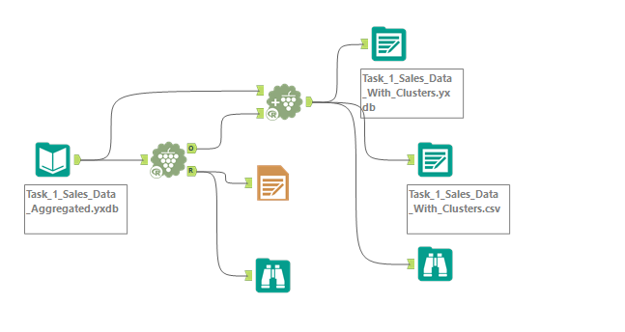

Task 2 Preparing Data

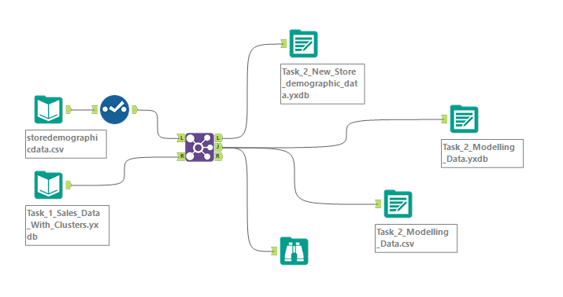

Task 2 Classification Model

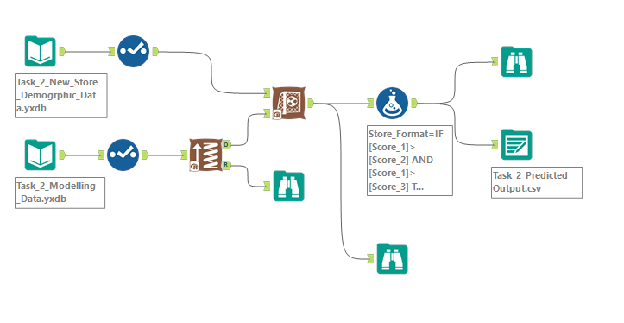

Task 3 Data Preparation

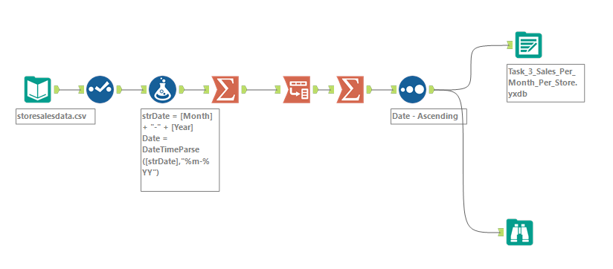

Task 3 Forecasting

